SWE645 Summer 2022

Homework 3 – Extra Credit

Maurice Joy, John DeCarlos

The front end and back end externalized configuration using environmental variables.

For the front end in Angular, APP_INITIALIZER was used in conjunction with a service to pull values from a config file. A template was set up with the environment variables and evnsubst was used in the docker file to populate the variables and write it to the config file. The variables are set with the front end deployment yaml. Two variables are used: 1) URL for backend RESTful API, and 2) Port for backend RESTful API. These values are added to the base URL for the HttpClient when using the GET() and POST() methods.

Figure Frontend.yaml env variables

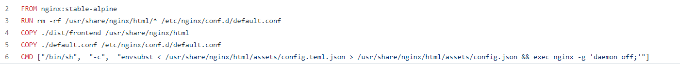

Figure Frontend Dockerfile

Figure config.teml.json for frontend

Figure service for loading config value

Figure Setting base URL from config value in service for GET()

For the backend, Spring Boot is set up to read from an application.properties file to pull in configuration settings. The file was populated with environment variables and these environment variables were set with the backend.yaml. The config settings used for the backend were: 1) Database URL, 2) Database username, 3) Database password, and 4) Port number for the embedded tomcat server to listen on.

Figure Backend application.properties

Figure Excerpt form backend.yaml